Expt.No.15 Keerthika.k
241901046

To Analyze the different types of servers using webalizer Tool

AIM:

To install Webalizer and analyze server log files to study server activity and traffic patterns.

INTRODUCTION

Webalizer is a web log analysis tool used to generate graphical reports from server log files. It helps in understanding server activity such as hits, visits, requested URLs, and client usage. In this experiment, Webalizer is used to analyze logs from a web server and study how different types of server requests are handled.

PROCEDURE:

1. Update the system using sudo apt update.

2. Install Apache server using sudo apt install apache2 -y.

3. Start Apache with sudo systemetl start apache2.

4. Install Webalizer using sudo apt install webalizer-y.

5. Generate traffic by accessing http://localhost/ or using curl.

6. Create Webalizer output directory:

7. sudo mkdir -p /var/www/html/webalizer

8. Run Webalizer on Apache logs:

sudo webalizer -o /var/www/html/webalizer/var/log/apache2/access.log

9.Open the browser and view the report at: http://localhost/webalizer

Output:
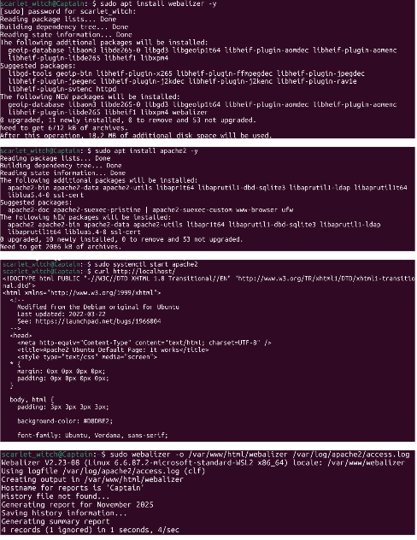
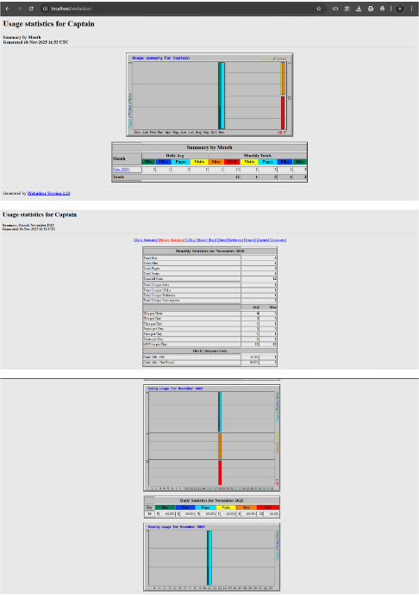

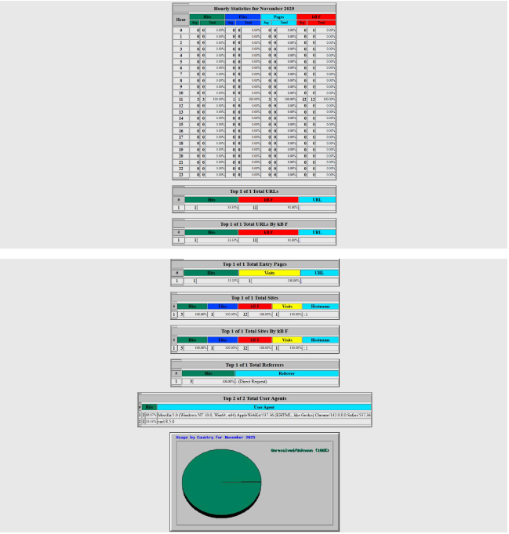
Result:
Webalizer was successfully installed and used to analyze the server logs. The generated reports displayed traffic details, server usage, and request statistics

